Counting backwards
What number comes next? | What number is missing?
9 8 ______ | ______ 8 7
6 ______ 4 | 12 ______ 10
3 ______ 1 | 10 11 ______
8 ______ 6 | 11 ______ 9
10 9 _____ | 8 7 ______
2 ______ 0 | ______ 5 4
7 ______ 5 | 10 ______ 8
11 12 ______ | 3 2 ______
______ 5 4 | 4 3 ______
5 ______ 3 | 9 ______ 7

Adding
Write the answer to each addition sum.
6 + 9 = | 9 + 2 =
8 + 3 = | 4 + 7 =
10 + 5 = | 7 + 6 =
4 + 8 = | 3 + 9 =
5 + 7 = | 8 + 5 =
7 + 8 = | 11 + 2 =
4 + 9 = | 6 + 6 =
6 + 5 = | 7 + 7 =
14 + 1 = | 12 + 3 =
8 + 6 = | 5 + 10 =
11 + 1 = | 13 + 2 =

Adding: Write the answer to each addition sum.
10 + 7 = | 14 + 5 =
19 + 1 = | 9 + 7 =
13 + 5 = | 7 + 9 =
4 + 16 = | 8 + 9 =
18 + 1 = | 2 + 15 =
17 + 2 = | 11 + 5 =
8 + 8 = | 9 + 11 =
4 + 15 = | 9 + 9 =
14 + 4 = | 13 + 3 =
1 + 16 = | 5 + 13 =
5 + 12 = | 13 + 6 =
0 + 17 = | 10 + 10 =
8 + 12 = | 12 + 7 =
6 + 11 = | 19 + 0 =
4 + 12 = | 2 + 16 =
15 + 5 = | 14 + 6 =
0 + 20 = | 15 + 1 =
17 + 3 = | 9 + 11 =
4 + 15 = | 9 + 9 =
14 + 4 = | 8 + 10 =
12 + 6 = | 14 + 7 =
15 + 0 = | 15 + 6 =

Subtracting
Write the answer to each subtraction below.
18 - 5 = | 11 - 1 =
17 - 0 = | 16 - 4 =
20 - 3 = | 15 - 4 =
13 - 2 = | 14 - 0 =
19 - 6 = | 20 - 2 =
19 - 2 = | 17 - 4 =
12 - 2 = | 16 - 5 =
19 - 3 = | 18 - 3 =
14 - 2 = | 12 - 1 =
16 - 3 = | 15 - 1 =
11 - 0 = | 12 - 2 =
20 - 10 = | 19 - 7 =
18 - 7 = | 19 - 6 =
14 - 1 = | 17 - 6 =
16 - 6 = | 18 - 8 =
20 - 3 = | 17 - 7 =
18 - 6 = | 20 - 8 =
16 - 2 = | 19 - 5 =
18 - 4 = | 14 - 4 =
13 - 3 = | 19 - 9 =
16 - 1 = | 17 - 5 =
20 - 9 = | 20 - 8 =

Multiplying
Complete the following:
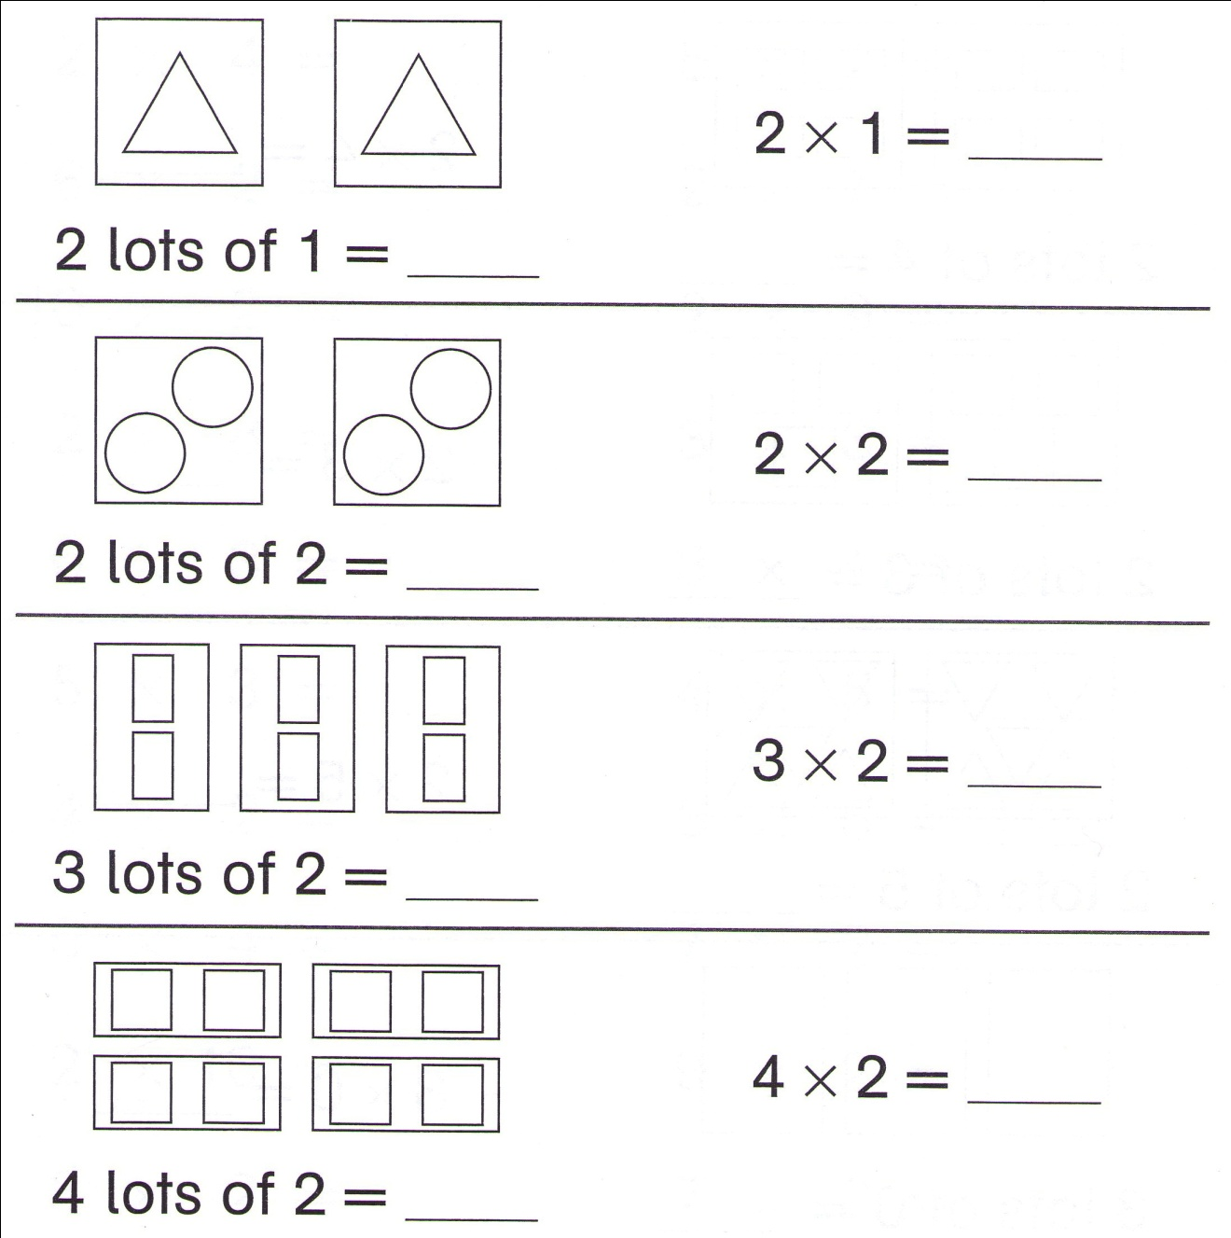
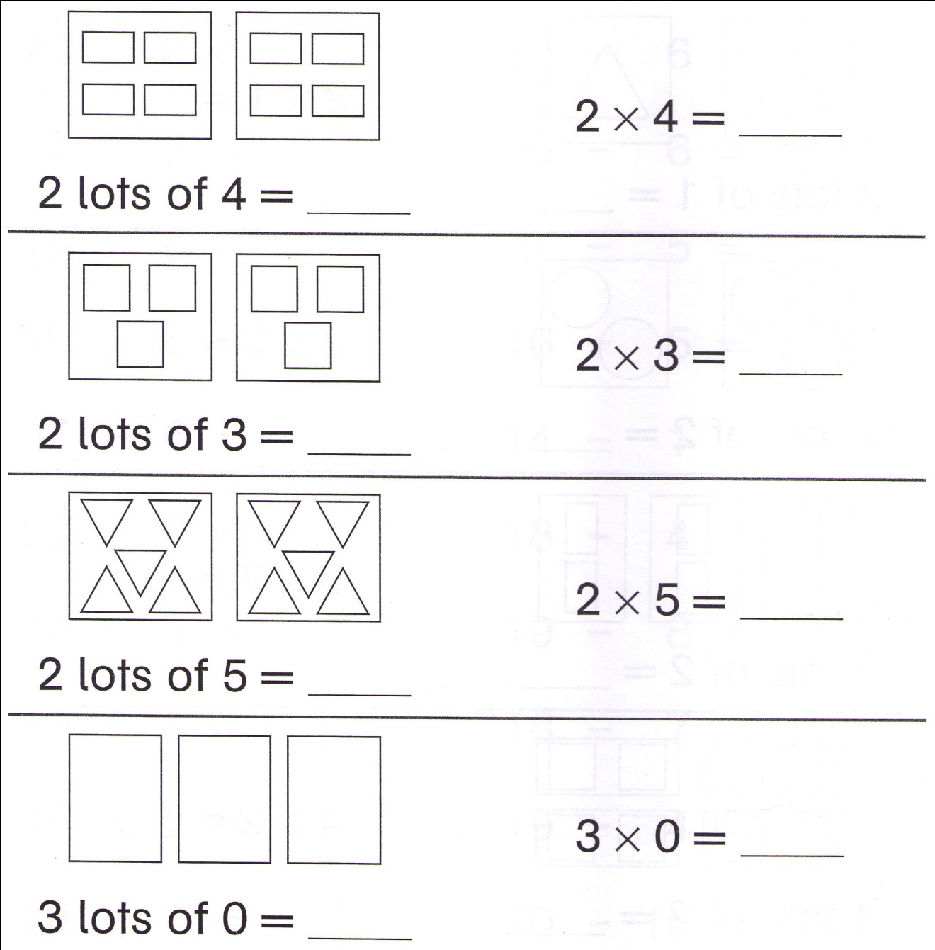

Multiplying
Write the answer to each of the following.
8 × 2 = | 2 × 3 =
2 × 4 = | 9 × 2 =
5 × 4 = | 2 × 7 =
10 × 2 = | 3 × 5 =
5 × 3 = | 3 × 3 =
6 × 3 = | 3 × 4 =
2 × 8 = | 4 × 5 =
4 × 2 = | 2 × 9 =
6 × 2 = | 5 × 2 =
1 × 2 = | 7 × 2 =
2 × 10 = | 7 × 0 =

Adding
How many legs altogether?
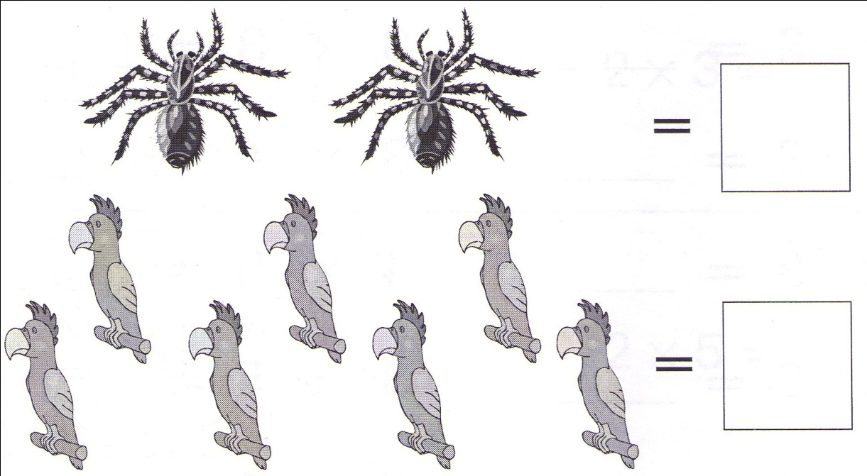
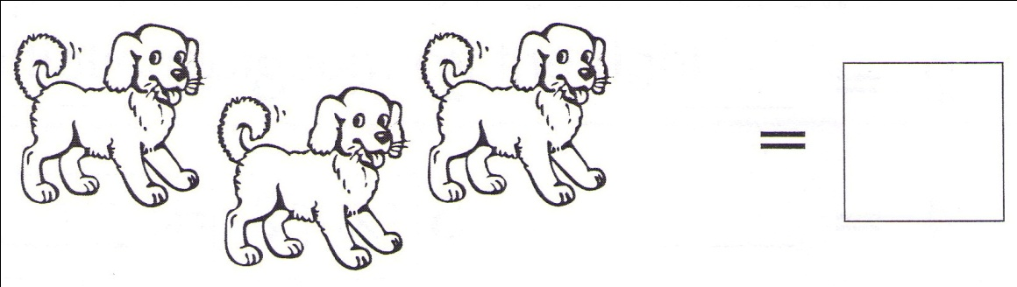
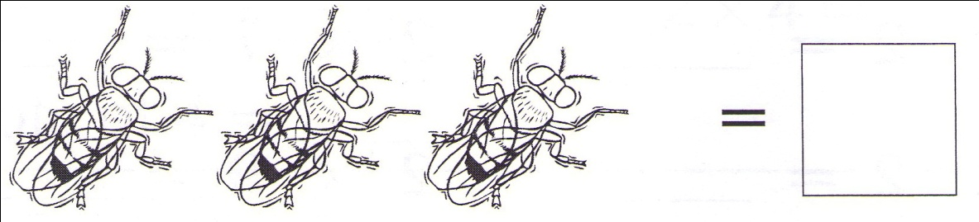
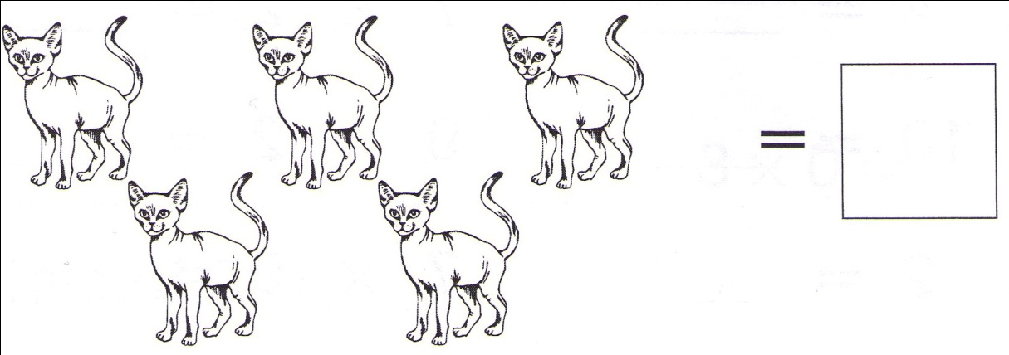
Sharing
- Here are 18 nuts. Share them evenly.
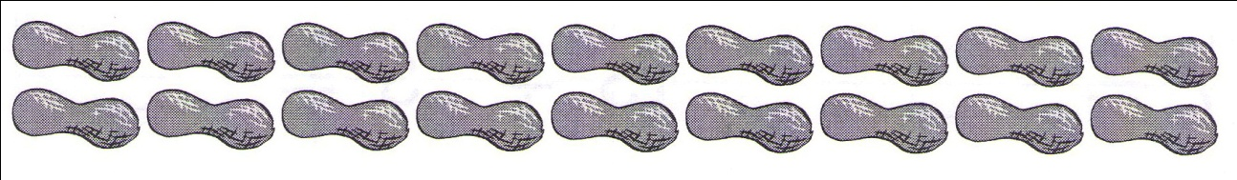
2 children would get ______ each.
6 children would get ______ each.
9 children would get ______ each.

- Here are 20 marbles. Share them evenly.
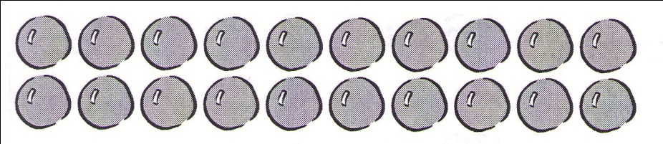
5 children would get ______ each.
4 children would get ______ each.

- Here are 12 lollies. Share them evenly.
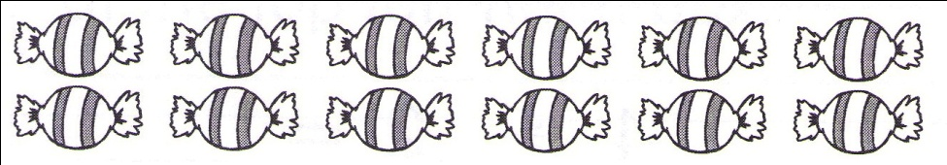
2 children would get ______ each.
3 children would get ______ each.
4 children would get ______ each.

Fractions
- Colour the correct fraction of each shape.
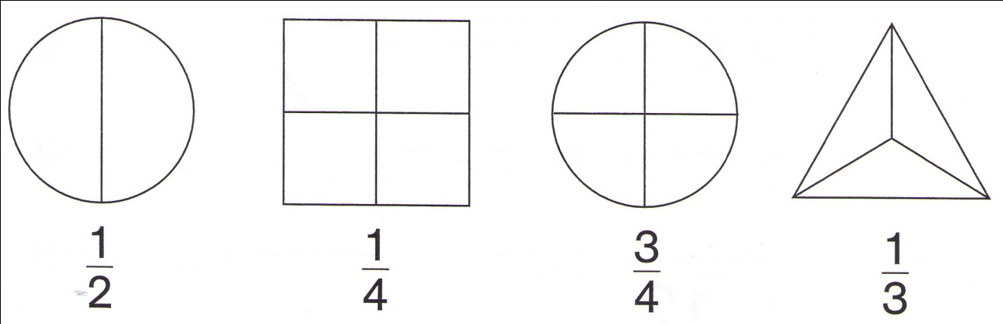

- Draw one or more lines to divide each shape. Colour them correctly.
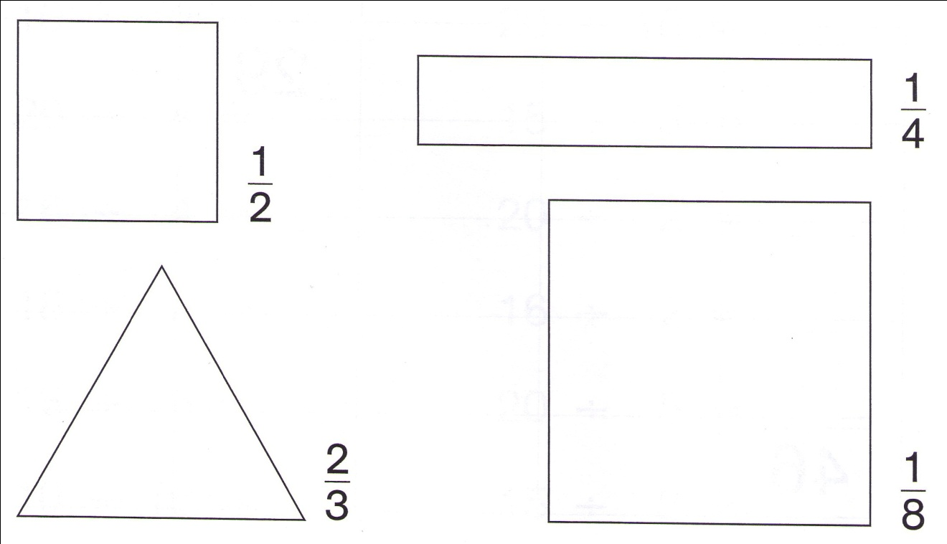

Problem Solving
- Ben has 7 tennis rackets. Tom has 2 tennis rackets. How many tennis rackets have they altogether?
______________________________

- Michael’s Mum bought 8 apples. Michael ate 3. How many apples were left?
_____________________________

- Jimmy has 16 oranges. Nick has 9 less than Jimmy. How many oranges has Nick?
_____________________________

- Bill has 6 cakes. Amy has 7 more than Bill. How many cakes do they have altogether?
_____________________________

- Adam has 16 marbles. Stephen has half as many as Adam. How many marbles do they have between them?
_____________________________

- In a race on the river there were 3 boats. In each boat 6 persons rowed. How many persons were in the race?
_____________________________

- There were 18 cans of coke on the table. Each child at the party drank 2 cans. How many children were at the party?
_____________________________

- A taxi takes 3 persons. How many taxis are needed to take 18 persons to catch a train?
_____________________________

- 5 jet bombers landed. Each plane had a crew of 4. How many men were flying the bombers?
__________________________

- Tom drinks 2 cups of milk every day. One week he had no milk on Saturday. How many cups of milk did he drink that week?
______________________________

