- Clothes to Wear
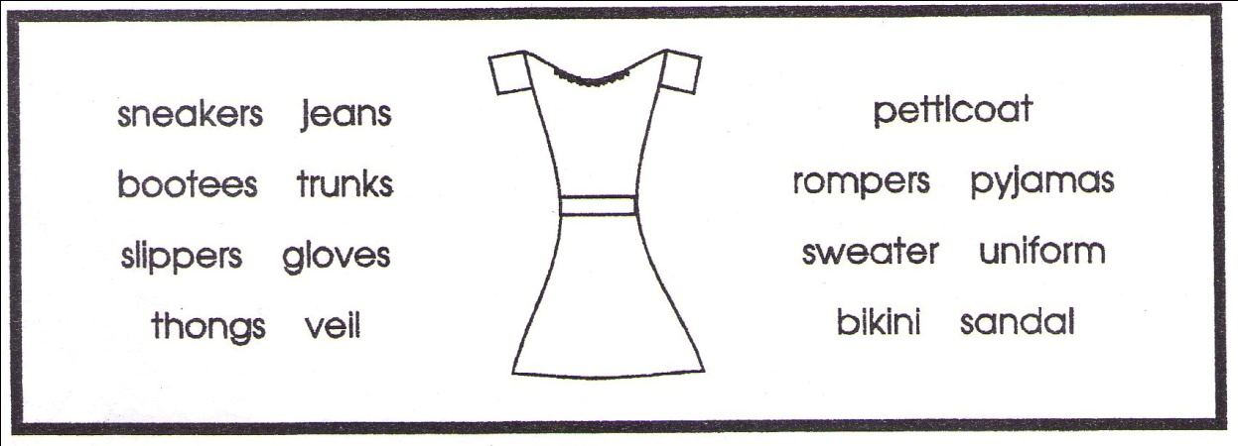
- A bridge sometimes wears a ____________ over her face.

- Boys and sometimes girls go to bed in a pair of ____________.

- A very small girl’s bathing suit is a ____________.

- ____________ are soft shoes worn in the home.

- We can put ____________ on our hand s to keep warm.

- A boy goes for a swim in a pair of ____________.

- In winter you wear a pullover which is also a ____________.

- A child about two years old plays in a pair of ____________.

- Mother wears a ____________ under her dress.

- A type of open leather shoe is a ____________.

- Baby wears a pair of woolen ____________ on his or her feet.

- Boys and girls wear strong pants that are called ____________.

- A person in the police or armed forces wears a special ____________.

- People wear rubber ____________ on their feet in summer.

- Rubber-soled shoes for playing sport are called ____________.

- Food and drink
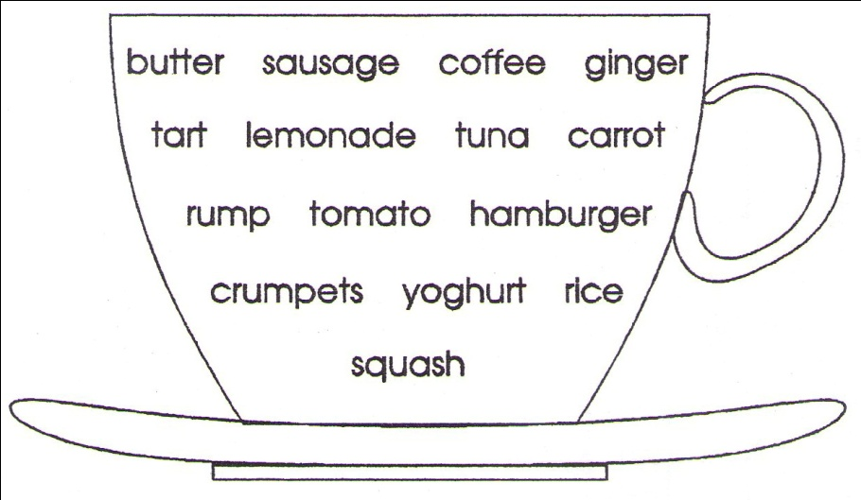
- ____________ is a drink made of roasted and crushed beans.

- ____________ is a grain that can be eaten with curry.

- ____________ is a hot spice made from a plant root.

- ____________ is a dairy food made from sour milk.

- Chopped meat and other foods put into a skin makes a ____________.

- A ____________ is a pastry filled with fruit and jam.

- Minced meat that is fried and put in a bun is a ____________.

- A ____________ is a red salad fruit also made into sauce.

- A ____________ is a vegetable that grows under the ground.

- ____________ is a cut of beef from the back of a beast.

- ____________ is made from cream and we spread it on bread.

- ____________ is a canned fish we buy in the supermarket.

- ____________ is a drink made of crushed oranges or lemons.

- We toast and put butter on ____________.

- ____________ is a fizzy drink sold in cans or bottles.

- Doing Words (Verbs)
forget repair cry choose tumble decide haul stroll construct stack approach tiptoe bustle raise slide shove worry relax prepare reason
- We ____________ when we do not remember.

- We ____________ when we push people or things.

- We ____________ when we are in a hurry.

- We ____________ when we come nearer.

- We ____________ things when we lift them.

- We ____________ when we try to work out a problem.

- We ____________ when we feel uneasy about something.

- We ____________ things when we mend them.

- We ____________ when we rest or stop working.

- We ____________ when we are in no hurry and walk slowly.

- We ____________ when we are in pain.

- We ____________ things on top of each other.

- We ____________ when we skate on ice.

- We ____________ when we fall.

- We ____________ things when we build them.

- We ____________ when we walk and try not to make a sound.

- We ____________ things when we make them ready.

- We ____________ when we make up our minds.

- We ____________ when we pull things.

- We ____________ when we pick or select from two or more things.

- Animals
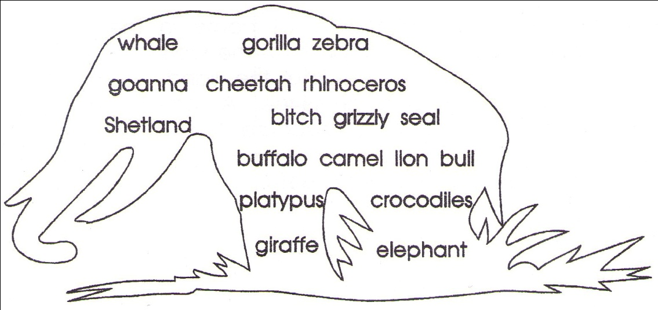
- The ____________ is an Australian reptile that climbs trees.

- A ____________ is a female dog.

- A large Canadian bear is the ____________.

- An animal once hunted by Red Indians is the ____________.

- The ____________ pony is very small but strong.

- The ____________ is heavy and has horns on its nose.

- A ____________ is a large and powerful ape.

- In some rivers of Australia there are man-eating ____________.

- A ____________ is a male cow.

- The largest cat and king of beasts is the ____________.

- The web-footed Australian ___________ has a duck’s bill.

- The ____________ is a striped animal like a horse.

- The animal known as the ‘ship of the desert’ is the ____________.

- The ____________ is a large wild cat that is the fastest animal.

- The world’s largest animal that lives in the sea is the ____________.

- The ____________ is the tallest animal in the world.

- Kinds of People
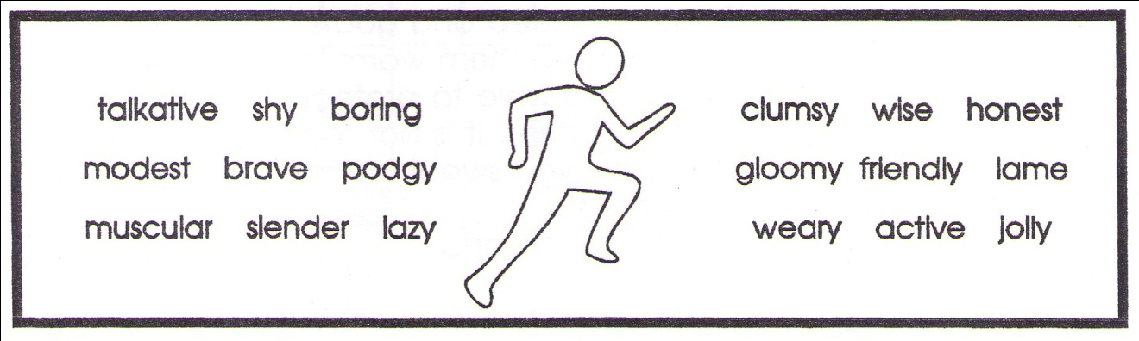
- A ____________ person tires us with his or her talking.

- A ___________ person is very strong.

- An ____________ person does not steal or tell lies.

- A ____________ is always smiling and happy.

- A ____________ person has something wrong with his or her leg.

- An ____________ person is always busy doing something.

- A ____________ person does not do or say silly things.

- A ____________ person never seems to stop talking.

- A ____________ person always seems to be tired.

- A ____________ person is not afraid.

- A ____________ person is rather fat.

- A ____________ person is not fat.

- A ____________ person always drops or knocks things over.

- A ____________ person does not like work.

- A ____________ person is always ready to help and be kind.

- A ____________ person does not like meeting strangers.

- A ____________ person never smiles and always feels sad.

- A ____________ person does not boast and does not show off.

- Jobs People Do
artist carpenter typist mechanic cobbler matron miner librarian pharmacist clown dentist jockey tailor conductor detective plumber
- An ____________ paints or draws pictures.

- A ____________ rides a horse in a race.

- A ____________ is a policeman who tries to solve crimes.

- A ____________ is in charge of a library where you find books.

- A ____________ repairs motor cars or other machines.

- A ____________ works on your teeth.

- A ____________ works in an office and types letters.

- A ____________ has a shop where he or she makes up medicines.

- A _____________ works in a circus and makes you laugh.

- A ____________ is in charge of nurses at a hospital.

- A ____________ repairs shoes that are worn.

- A ____________ measures then makes suits or clothes for you.

- A ____________ builds the wooden parts of a house.

- A ____________ repairs or put pipes and taps in houses.

- A ____________ digs for coal or other minerals.

- A ____________ collects fares on a train or bus.

- A (furrier florist farrier) ____________ sells flowers.

- A (purser ganger juggler) ____________ performs tricks.

- Parts of the Body
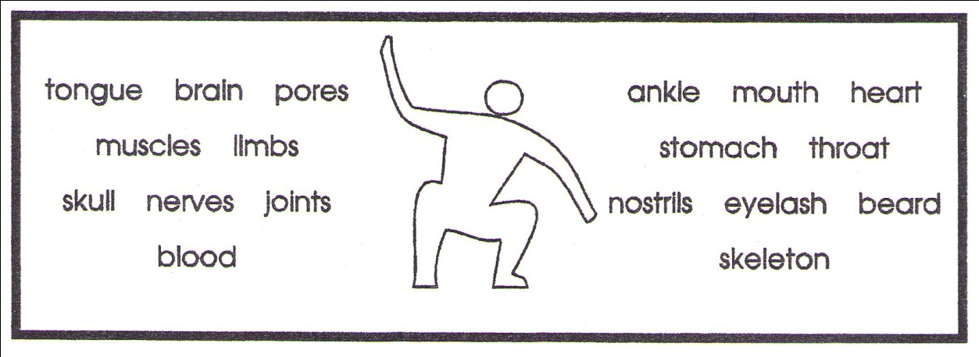
- The ____________ is the part of your body that does the thinking.

- All the bones of the body make up the ____________.

- The part where your foot joins the leg is the ____________.

- Hair on a man’s face is called a ____________.

- A word used for arms or legs is ____________.

- Sweat comes out from your skin through tiny ____________.

- Your ____________ beats and acts as a pump for the blood.

- Many of your bones move at the ____________.

- Your ____________ which is in the ____________ helps you talk.

- A hair above or below the eye is called an ____________.

- Your brain is protected by bones which form the ____________.

- Food goes down to the ____________ to be used by the body.

- Air and food passes down your ____________.

- To make the bones move we have many ____________ in the body.

- Your ____________ carries food to cells and is pumped by the heart.

- The holes in your nose are called ____________.

- You felt pain through the ____________ in your body.

- Crossword
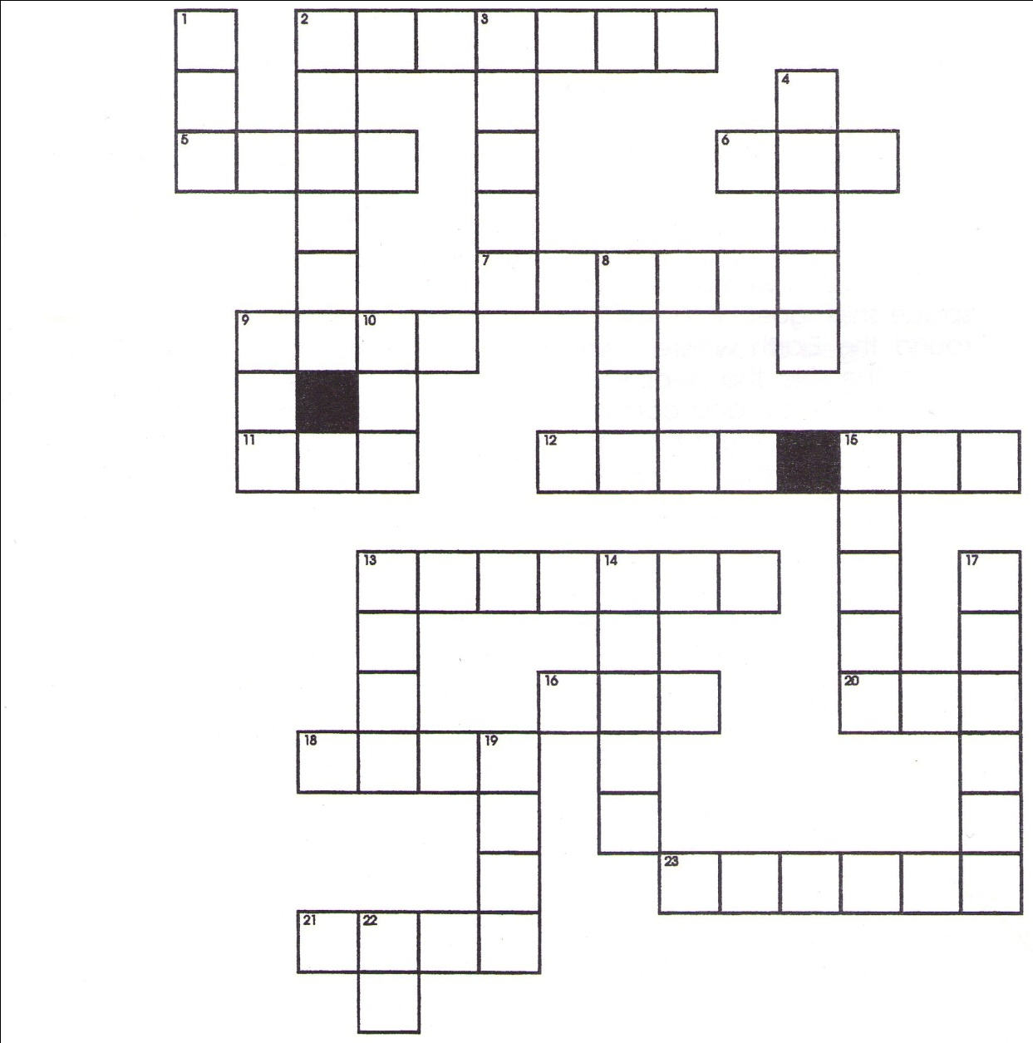
Across
2 opposite of ‘inside’
5 It sails on the sea.
6 You ___ with a knife.
7 We ___ with our ears.
9 You can eat roast ___ for dinner.
11 the Father of Jesus
12 You can ___ with a rope.
13 part of a bird’s wing
15 opposite of ‘happy’
16 a word that joins words
18 Seals ___ on fish.
20 not old
21 You can ___ flowers.
23 They fly in the sky.
Down
1 short word meaning ‘taxi’
2 a round fruit
3 A snail lives in one.
4 A fire ___.
8 ill
9 You can drink from one.
10 ___ 3 and 3 to make 6
13 It burns.
14 Bees make it.
15 five plus two
17 all the time
19 It is ___ at night.
22 not out

